BID PROPOSAL

Date: _______________

ATTY. MARIANO PABLO S. TOLENTINO
Acting Head, Asset Management Division
5th Floor, c/o Investment Property Department SSS Building, East Avenue,
Diliman, Quezon City

SIR:

I/We refer to the invitation of the Social Security System to Prospective Lessees to apply for eligibility and submit competitive lease proposal for the Twenty Five (25)-Year Lease of the Twelve (12) SSS-owned Residential Units in Urdaneta Village, Makati City.

Relative thereto, our company (state name of the Corporation/Lead Member Corporation), hereby, formally submits this lease proposal:

Bid Item and Area | :
Bid Price/ Rental Rate | :
 |  | (P per square meter, Amount in words and figures, VAT Excl.)
20% of Estimated Cost of Improvement/ Development | :

The undersigned is duly authorized by the Company to make this proposal for and on its behalf. Submitted by:

(signature)

Name of Authorized Representative

Position

REPUBLIC OF THE PHILIPPINES
CITY OF ) s.s.

ELIGIBILITY STATEMENT
I, , of legal age, (nationality), with address at
, under oath, hereby depose and say THAT:

  - The (name of Company/Prospective Lessee) with office address at (address of Prospective Lessee) is interested to participate in the public bidding proceedings for the Twenty Five (25)-Year Lease of the Twelve (12) SSS-owned Residential Units in Urdaneta Village, Makati City;

- I am the (designation) of the (Prospective Lessee), duly authorized to make this Statement for and on its behalf;

- The (Prospective Lessee) has no pending or unpaid tax liabilities in the Philippines;

- The (Prospective Lessee) has not been disqualified or is not “blacklisted” or barred from bidding by any government agency, instrumentality, GOCC or any bilateral or multilateral agency such as but not limited to the Asian Development Bank and the World Bank, by itself or by relation, membership, association, affiliation, or controlling interest with another blacklisted person or entity as defined and provided for in the Uniform Guidelines on Blacklisting;

- The (Prospective Lessee) acknowledges that it has inspected the property for lease and accepts the Terms of Reference, qualification criteria and the terms and conditions set by SSS;

- The (Prospective Lessee), if awarded the contract to lease the Subject Property, commits to comply with the rules, regulations and standards set by the SSS and all other pertinent and relevant laws, rules, regulations and issuance of the agencies of the National Government and of the Local Government, for the entire duration of the contract period;

- The (Prospective Lessee) commits to abide by the decision of the Recommending Authority (RA), waives any right to seek and obtain a writ of injunction or prohibition or restraining order against the Social Security Commission (SSC), SSS, RA, Technical Working Group (TWG), SSS officers and staff, to prevent or restrain the qualification proceedings related thereto, the award of the contract to a successful Prospective Lessee, and the carrying out of the awarded lease contract;

- Each of the documents submitted in satisfaction of the eligibility requirements is an authentic and original copy, or a true and faithful reproduction or copy of the original, complete, and all statements and information provided herein are true and correct. Any falsity, error, or misrepresentation shall constitute a ground for disqualification from this bidding proceedings or revocation of award as determined by SSS;
- The (Prospective Lessee) authorizes the SSS or its duly authorized representative/s to verify all of the documents submitted and authorizing SSS to check or review, at any time during the evaluation process, other relevant information affecting the PL or the Lease Proposal and should such review uncover any misrepresentations made in the Eligibility Documents or the Bid Proposal, or any change in the situation of the PL (including all the members of the JV or consortium), which affects the substance of its Lease Proposal, SSS may disqualify the PL from the bidding procedures and forfeit the PS, if posted;

- (Prospective Lessee), its Directors, Officers and staff or any representative thereof, shall not attempt to establish any contact with any member of the SSC, SSS officers and staff, the RA, TWG, RA Secretariat on matters concerning this undertaking from the date of submission of the Lease Proposal up to the conclusion of the bidding process.

- The (Prospective Lessee), its Directors and Officers have neither given nor offered, nor will it give nor offer, directly or indirectly, any bribe or other improper payment advantage to any SSC member, SSS officers and staff, RA, TWG and RA’s Secretariat, or engage in any of the acts prohibited under R.A. 3019, otherwise known as the “Anti-Graft and Corrupt Practices Act”, as amended.

- The (Prospective Lessee) is not involved in any money laundering activity as defined by the Anti-Money Laundering Act of 2001 (RA 9160).

IN FAITH WHEREOF, I have hereunto affixed my signature this day of at
,Philippines.

[Insert NAME OF BIDDER OR ITS AUTHORIZED REPRESENTATIVE]
[Insert signatory’s legal capacity]
Affiant

[Jurat]
[Format shall be based on the latest Rules on Notarial Practice]

SAMPLE FORM – WAIVER OF RIGHT TO SEEK LEGAL REMEDIES

Date

THE ACTING HEAD

Asset Management Division Social Security System
5th Floor, c/o Investment Property Department SSS Building, East Avenue, Diliman , Quezon City

Subject: Twenty Five (25)-Year Lease of the Twelve (12) SSS-owned Residential Units in Urdaneta Village, Makati City

Sir/Madam:

As a duly authorized representative of [Name of Company], (hereinafter referred to as the “Company”), and in connection with the Invitation to Bid for the lease of the subject properties on an “as-is where-is basis”, the undersigned on behalf of the Company, hereby expressly and formally commits to abide by the decision of the Recommending Authority (RA) for the subject property to determine the eligibility of Lessees as well as the eventual Winning Lessee (WL) among them, if any.

Accordingly, and in accordance with the Terms of Reference (TOR) for the public bidding of the subject SSS property, the Company hereby holds the SSS free and harmless from any liability, costs and expenses, suit or allegation arising out of the Company’s participating in the bidding process. This also serves as a formal waiver by the Company of any right to file any form of legal remedy or action before any court, tribunal or administrative body to prevent or restrain or prohibit SSS from continuing the bidding proceedings related thereto and from awarding and executing a contract with the WL as determined by the RA.

Very truly yours,

Authorized representative (Please enclose letter of authority) Name and Signature: Title/Position :
Date :

REPUBLIC OF THE PHILIPPINES) CITY/MUNICIPALITY OF ) S.S.

AFFIDAVIT
I, [Name of Affiant], of legal age, [Civil Status], [Nationality], and residing at [Address of Affiant], after having been duly sworn in accordance with law, do hereby depose and state that:

Select one, delete the other:

[If a sole proprietorship:] I am the sole proprietor or authorized representative of [Name of Prospective Lessee] with office address at [address of Prospective Lessee];
[If a partnership, corporation, cooperative, or joint venture:] I am the duly authorized and designated representative of [Name of Prospective Lessee] with office address at [address of Prospective Lessee];

Select one, delete the other:

[If a sole proprietorship:] As the owner and sole proprietor, or authorized representative of [Name of Prospective Lessee], I have full power and authority to do, execute and perform any and all acts necessary to participate, submit the bid, and to sign and execute the ensuing contract for [Name of the Project] as shown in the attached duly notarized Special Power of Attorney;

[If a partnership, corporation, cooperative, or joint venture:] I am granted full power and authority to do, execute and perform any and all acts necessary to participate, submit the bid, and to sign and execute the ensuing contract for [Name of the Project], as shown in the attached [state title of attached documents showing proof of authorization (e.g., duly notarized Secretary’s Certificate, Board/Partnership Resolution, or Special Power of Attorney, whichever is applicable;)];

Select one, delete the rest:

[If a sole proprietorship:] [Name of Prospective Lessee] is not related by consanguinity or affinity within the third civil degree to any member of the Social Security Commission, the SSS President and CEO, any of the Recommending Authorities (RAs), or any SSS approving authorities, or any employee of the SSS Asset Management Division;

[If a partnership or cooperative:] None of the officers and members of [Name of Prospective Lessee] is related by consanguinity or affinity within the third civil degree to any member of the Social Security Commission, the SSS President and CEO, any of the RAs, or any SSS approving authorities, or any employee of the SSS Asset Management Division;

[If a corporation or joint venture:] None of the officers, directors, and controlling stockholders of [Name of Prospective Lessee] is related by consanguinity or affinity within the third civil degree to any member of the Social Security Commission, the SSS President and CEO, any of the RAs, or any SSS approving authorities, or any employee of the SSS Asset Management Division;

IN WITNESS WHEREOF, I have hereunto set my hand this day of , 20 at
, Philippines.

[Insert NAME OF BIDDER OR ITS AUTHORIZED REPRESENTATIVE]
[Insert signatory’s legal capacity]
Affiant

[Jurat]
[Format shall be based on the latest Rules on Notarial Practice]

Annex J

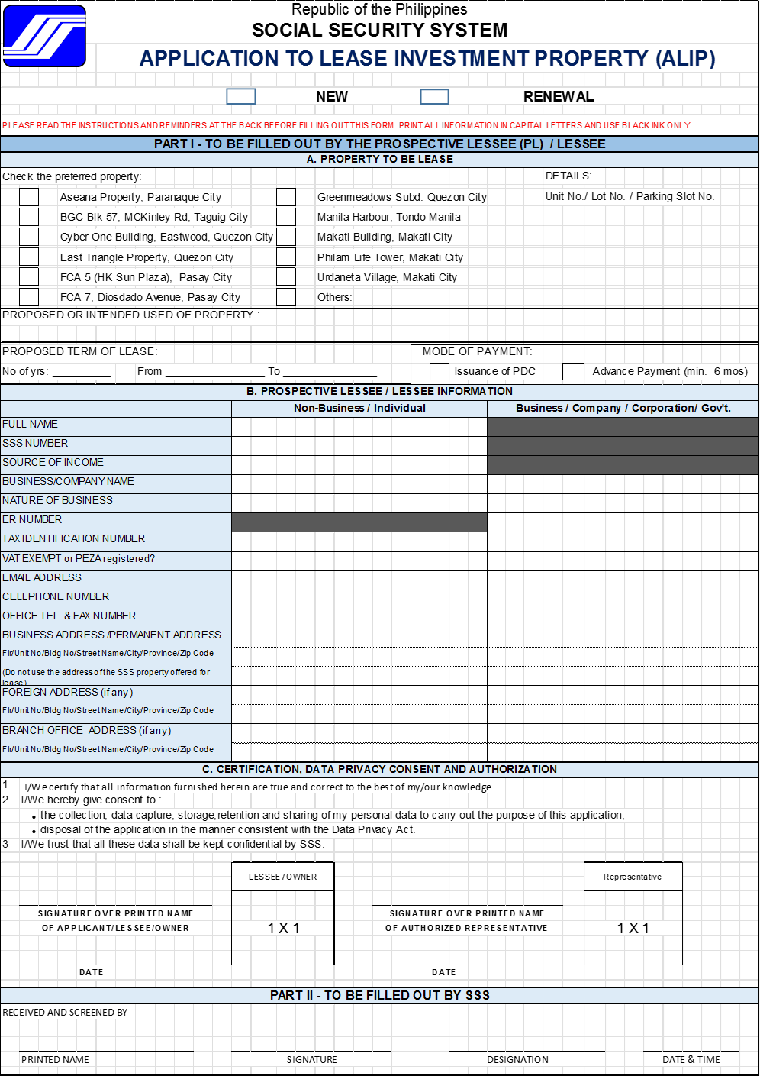

REPUBLIC OF THE PHILIPPINES
CITY OF ) s.s.

PROPOSAL SECURING DECLARATION
(shall be submitted with the Bid and Proposal Security)

To: [Insert name and address of the Leasing Entity]

I/We, the undersigned, declare that:

- I/We understand that, according to your conditions, a prospective lessee shall also submit a Proposal Securing Declaration simultaneous to the posting of Proposal Security.

- I/We warrant that the proposal security submitted shall be valid for a period of one hundred eighty (180) calendar days from the date of the opening of the lease proposals;

- I/We, when selected as the winning lessee, shall enter into contract with SSS and furnish the required Security Deposits from receipt of the Notice of Award and prior to the execution of the contract of lease;

- I/We acknowledge that SSS reserves the right to disqualify me/us for a period of time from participating in any of its selection/procurement activity, regardless of mode, in the event I/we violate any of the conditions stated herein including but not limited to, not entering into the contract of lease with SSS when selected, or failure to perform its obligations under the said contract;

- I/We acknowledge that the proposal security shall automatically be forfeited in favor of the SSS in the event that I/we withdraw my/our proposal during its validity, fail to and/or refuse to enter into a contract with the SSS when selected or when there is a failure to furnish the required security deposit.

IN FAITH WHEREOF, I/We have hereunto affixed my signature this day of at
, Philippines.

Name of Prospective Lessee/Authorized Representative

[Jurat]
[Format shall be based on the latest Rules on Notarial Practice]

CHECKLIST OF DOCUMENTS

Documents
Eligibility Documents to be contained in the First Envelope

For Company/Business or Individual
1. Duly notarized Eligibility Statement (Annex G)
2. Waiver of right to seek legal remedies (Sample - Annex H);
3. Sworn affidavit of the PL or its duly authorized representative stating that he/she or any officer of its corporation/ partnership/ institution/JV or consortium members, is not related within the third civil degree of consanguinity or affinity to any members of the SSC, the PCEO, any of the approving authorities, or any of the employees of the Asset Management Division (AMD) (Sample - Annex I).
4. Application to Lease Investment Property (ALIP) (Annex J);
5. Bank Statement with cash balance as stated in this TOR or a committed Line of Credit from a reputable Commercial/Universal Bank with amount as stated in this TOR;
6. Proof of Checking Account under the PL’s name for issuance of post-dated checks;
7. Certification under oath by the PL or its authorized representative that each of the documents submitted in satisfaction of the eligibility requirements is an authentic and original copy, or a true and faithful reproduction or copy of the original, complete, and that all statements and information provided therein are true and correct (see Annex G, Item 8);
8. A letter or Certification under oath by the PL or its authorized representative authorizing SSS or its duly authorized representative/s to verify all of the documents submitted and authorizing SSS to check or review, at any time during the evaluation process, other relevant information affecting the PL or the Lease Proposal and should such review uncover any misrepresentations made in the Eligibility Documents or the Bid Proposal, or any change in the situation of the PL (including all the members of the JV or consortium), which affects the substance of its Lease Proposal, SSS may disqualify the PL from the bidding procedures and forfeit the PS, if posted (see Annex G, Item 9);
9. Any government-issued identification card (SSS, GSIS, UMID, Passport, Driver’s License).
For Company/Business
10. Registration Certificate from Securities and Exchange Commission (SEC) for corporations and partnerships, Department of Trade and Industry (DTI) for sole proprietorship, or Cooperative Development Authority (CDA) for cooperatives or a license to do business in the Philippines, if foreign entity;
11. Articles of Incorporation/ Partnership and By-Laws of the Prospective Lessee (PL) as amended by the latest amendments, or revisions if any;
12. Mayor’s or Business permit issued by the city or municipality where the principal place of business of the PL is located;
13. A Board Resolution duly certified by the PL's Corporate Secretary, if applicable, expressly authorizing the corporation's participation in the bidding process, nominating, appointing and authorizing a representative to communicate, represent, sign and execute contracts and other documents relative thereto;
14. The PL’s Audited Financial Statements stamped “received” by the Bureau of Internal Revenue (BIR) or its duly accredited and authorized institutions, for the Calendar/Fiscal Year 2021;
15. Income tax return corresponding to the submitted Audited Financial Statements and Business tax returns (e.g. Value Added Tax returns and/or percentage tax returns) for the last six (6) months and an updated tax clearance issued by the BIR;
- If a JV or consortium, the PL (including all its JV/consortium members) shall submit to SSS a copy of the duly notarized JV Agreement/Memorandum of Agreement/Understanding which:
  - briefly describes the JV/consortium, the individual members of the JV/consortium and the extent of the participation of each member;
  - identified the lead member of the JV/consortium who is authorized by all members to represent and sign any and all documents related to this process, receive notices/instructions and to make payments for and on behalf of the JV/consortium; and
  - provides that the members shall be jointly and severally liable for the obligations of the PL under the award/COL

SSS requires that each and every JV or consortium member shall submit all of the above Eligibility Documents, or, in the case of a foreign entity, its appropriate equivalent document, if any, issued by the foreign entity’s country. All equivalent foreign documents must be in English. A translation of the documents in English certified by the appropriate embassy or consulate in the Philippines must accompany the documents if they are in other foreign languages. All PLs, including all members of the JV or consortium, shall be subject to the eligibility requirements.
If an Individual bidder (NON-BUSINESS), in addition to the above-mentioned:
- Certificate of Employment and Compensation (CEC) or Certification Under Oath of Source of Income;
- Latest Income Tax Return (ITR), if applicable;
If a Government Entity
- Application to Lease Investment Property (ALIP);
- Board Resolution authorizing the lease transaction as well as the authorized signatory to enter/sign/execute the Contract of Lease (COL);
- Copy of the applicable law creating the government entity;
- Proof of Fund Availability.
Bid Proposal to be contained in the Second Envelope
1. Bid Proposal (Sample - Annex E)
2. Proposal Security (in Cash or Manager’s Check)
3. Proposal Securing Declaration (Sample - Annex K)

